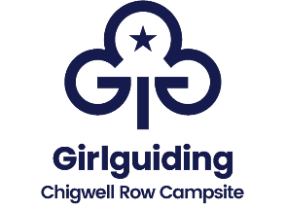
“Come 2 Camp 2024”
Guide and Ranger Weekend Camp
Friday 28th^{th} June to Sunday 30th June 2024

Event Registration Form
On returning this form to us you will receive a provisional booking form and a deposit request to secure your booking.

Unit Name: _________________________________________________

Leader’s Name: ______________________________________________

Leader’s Membership Number: ____________________________________

Contact Phone Number(s): _______________________________________

Contact Email Address: _________________________________________

Correspondence Address_________________________________________

__________________________________________________________

Post Code: _______________________

Number of Adult Leaders / Members  Come2Camp |  | Number of Rangers  Come2Camp
Number of Guides  Come2Camp |  | Number of Brownies  (aged 10+ only)  Come2Camp

Signed: ____________________ (Leader) Date: __________________

In accordance with Girlguiding’s GDPR policy, data provided above will only be used for the specific
purpose it was collected for. It will be stored securely and destroyed when no longer needed.
Girlguiding is the registered data controller* for all our members’ personal information, both in the UK and around the world. Want to find out more about how we use your information – and your rights? Visit girlguiding.org.uk/privacy-policy * The organisation that manages and looks after your data

