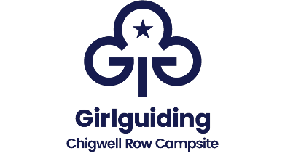
Event Registration Form
Summer Fun 2024
Chigwell Row Campsite
Saturday 6th - Sunday 7th July 2024
Managed by London over
the Border County

On returning this form to us you will receive a provisional booking form and a deposit request to secure your booking.
Unit Name: _________________________________________________

Name: ______________________________________________

Membership Number: ____________________________________

Contact Phone Number(s): _______________________________________

Contact Email Address: _________________________________________

Correspondence Address_________________________________________
__________________________________________________________

Post Code: _______________________
I wish to attend both days | I wish to attend Saturday only |  | I wish to attend Sunday only
Overnight guests only
I would prefer an accommodation space in a shared tent. |  | I would prefer an accommodation space in a shared room

Signed: ____________________ Date: __________________
To register, please complete the ‘Booking Form’ & return it to us.
For more information contact us at
Girlguiding Chigwell Row, 141 Lambourne Road, Chigwell Row, Essex, IG7 6EN
website: www.chigwellrow.org.uk info@chigwellrow.org.uk
Telephone: 020 8500 2450

